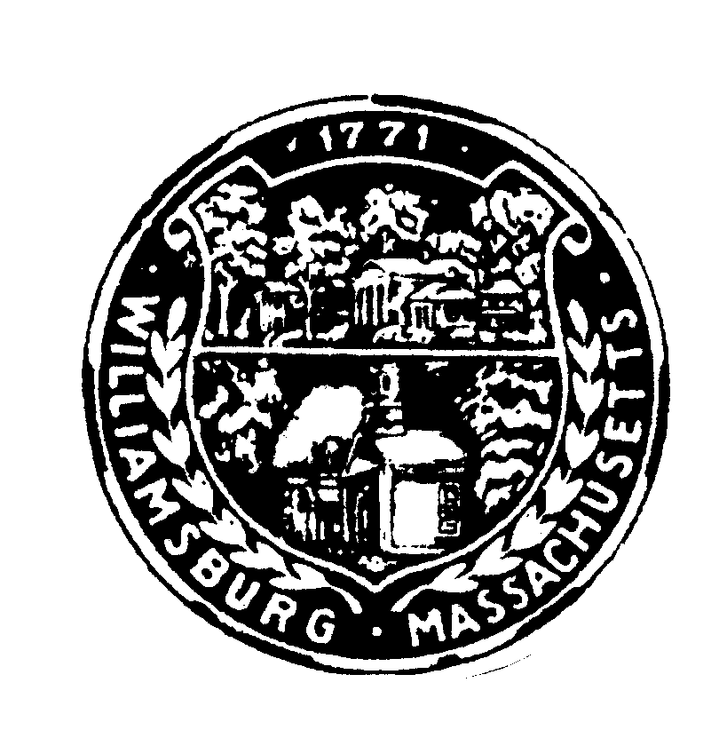
Williamsburg Conservation Commission
147 Main Street, P.O. Box 447
Haydenville, Massachusetts 01039-0447
Phone: 413-268-8416 Fax: 413-268-8409
conservation@burgy.org

Agenda
Town Offices, 7:00 pm.
October 12, 2017

- RDA submitted by Jean O’Neil for construction of a shed at 91 Chesterfield Rd
- Consideration of applicant for Conservation Commission Secretary

Other business, including discussion of issues raised after the posting of the agenda

Reading of minutes from

Reading of the mail

