PUBLIC SAFETY COMPLEX REPORT
Since the Facilities Master Planning Committee completed its report in December, utilizing a $16,000 planning grant with Pioneer Valley Planning Commission, the Williamsburg Public Safety Complex Committee (WPSCC) has moved ahead to implement the report’s recommendations wherever possible. The report highlighted several areas that have provided the WPSCC with additional guidance on how and where to proceed. The primary recommendation was to preserve the Helen E. James building for town office and open space use, if possible. This has entailed a reevaluation of previous work done to ensure that we haven’t overlooked any potential properties that might be utilized for the location of a safety complex. Below you will find excerpts from the report that highlight two sites that we are continuing to investigate in more depth. This work will make sure we consider the best choices possible given the many issues involved in the project.
We are also paying close attention to recommendations in the report and from feedback that we have received to keep costs as low as possible while maintaining support for the departments’ missions. We continue to explore alternative construction and purchasing methods and to reexamine the programming requirements of the departments’ requests to keep these costs down. We will make every effort to follow the Capital Budget recommendations when it is established as recommended in the Facilities report.
The town can look forward to an open discussion forum and presentations at various events in town between now and a special town meeting in the fall to authorize the hiring of a designer. Please contact any of us for further information or for questions (http://www.burgy.org/public-safety-complex-committee), and come to the presentations to help us all achieve the best outcome.
Many thanks to those who have already contributed their thoughts and ideas on the project. They have been very helpful.
Williamsburg Public Safety Complex Committee
--------------------------- [From Facilities Master Plan Committee Report: Pros and Cons are not shown in any order of importance]--------------------------
16 Main Street (Helen E James School site)
Pros:
- Town-owned property
- Large, relatively flat site
- Adequate water volume and pressure for sprinkler system
- Plans for building on site have already been developed by architects
- Good vehicular access with reasonable sight lines
- Plans, as drawn by DRA, avoid flood plains

Cons:
- Wetland and floodplain issues significantly reduce buildable area on site, which constrains options for building and site design. DRA Architects found that there is sufficient space to build on the site if the building reaches just up to the edge of the regulated floodplain.
- Orientation of HEJ building on site makes adding another building on that site difficult to fit in while retaining space for other uses (open space, greenway, etc.).
- Existing greenspace has high value. Williamsburg’s last opportunity for a Town green.
- Site is very prominent and contributes to character of Burgy center significantly. Building and site design may require a higher level of design than other locations in Town in order to not degrade the current appeal of the Town Center.
- Future Mill River Greenway crosses site. A very wide driveway (as shown in DRA drawings) conflicts with pedestrian and bicycle use of the area.
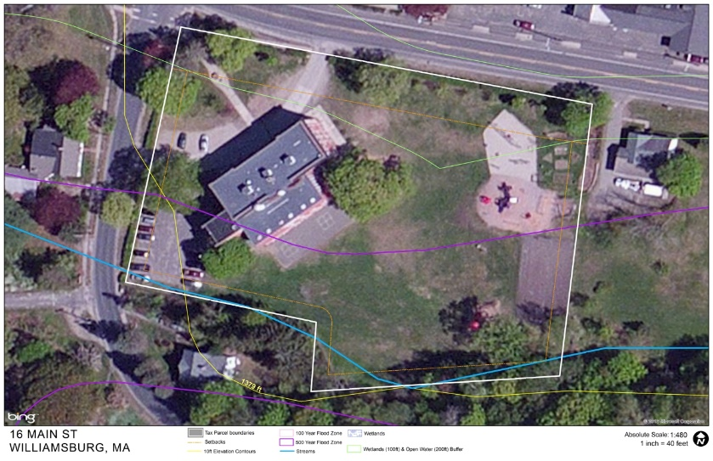
- Development of public safety complex could reduce reuse possibilities of the HEJ building (especially for non-municipal use like housing or office.

__________________________________________________________________________________________

45 Main Street (between Lashway lot and Elbow Room Coffee)

Pros
- Large, relatively flat site
- Burgy center location provides fast emergency response to most households
- Public safety complex as show in DRA 2.1 with double-loaded bays would fit within buildable area of site.
- Public safety complex fits context better than one at the HEJ site. A pre-engineered building is similar to the character of adjacent buildings
- While expansive driveway would not be pedestrian or bicycle friendly, impact is less severe than the same driveway located in Burgy or Haydenville centers.
- Leaves the HEJ site with maximum possibilities for reuse
- 45 Main St. could be expanded if 37 Main St. was also acquired.

Cons
- It is unknown whether the site is available (note: site is available)
- Would likely require purchase which would increase cost of project
- Water supply is not adequate for sprinkler system. Requires water storage and booster. Adds cost to project.
- Floodplain and wetlands/river regulations restrict buildable area, but buildable area is adequate for public safety complex as show in DRA 2.1, including double-loaded bays.
- Flooding on Route 9 both east and west of this site has happened in recent memory. This site could be marooned in a severe flood event.
- Removes prime commercial property from tax rolls.
- Requires demolition.
